Module 1 and 2 assessment questions.

1. Consider a case, a folder has multiple files and how would copy it to destination machine path (Try using SCP, cp options in Linux)
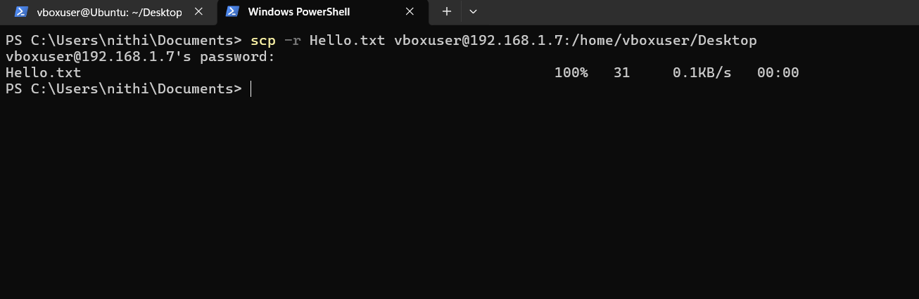
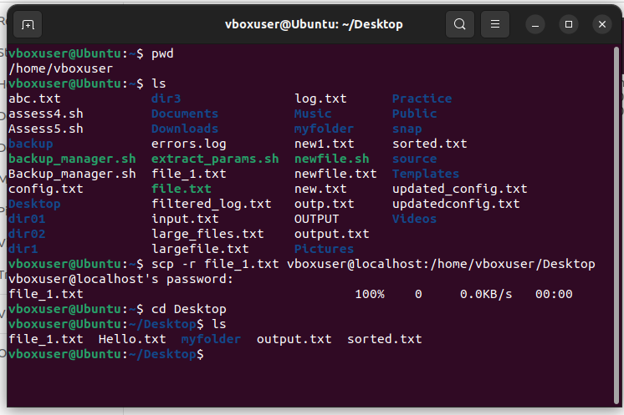

2. Host a FTP and SFTP server and try PUT and GET operations.
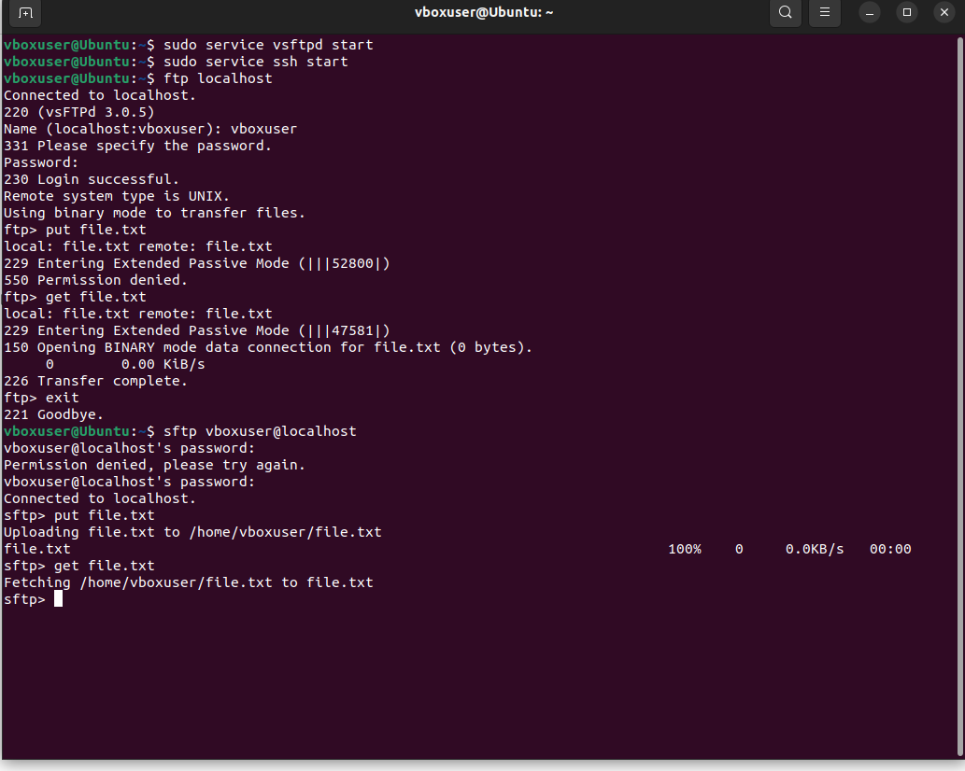

3. Explore with Wireshark/TCP-dump/cisco packet tracer tools and learn about packets filters.
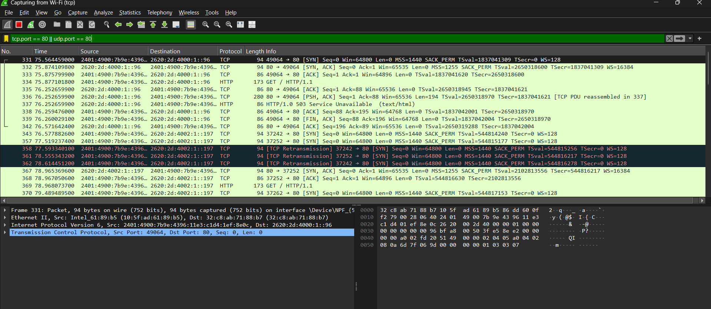

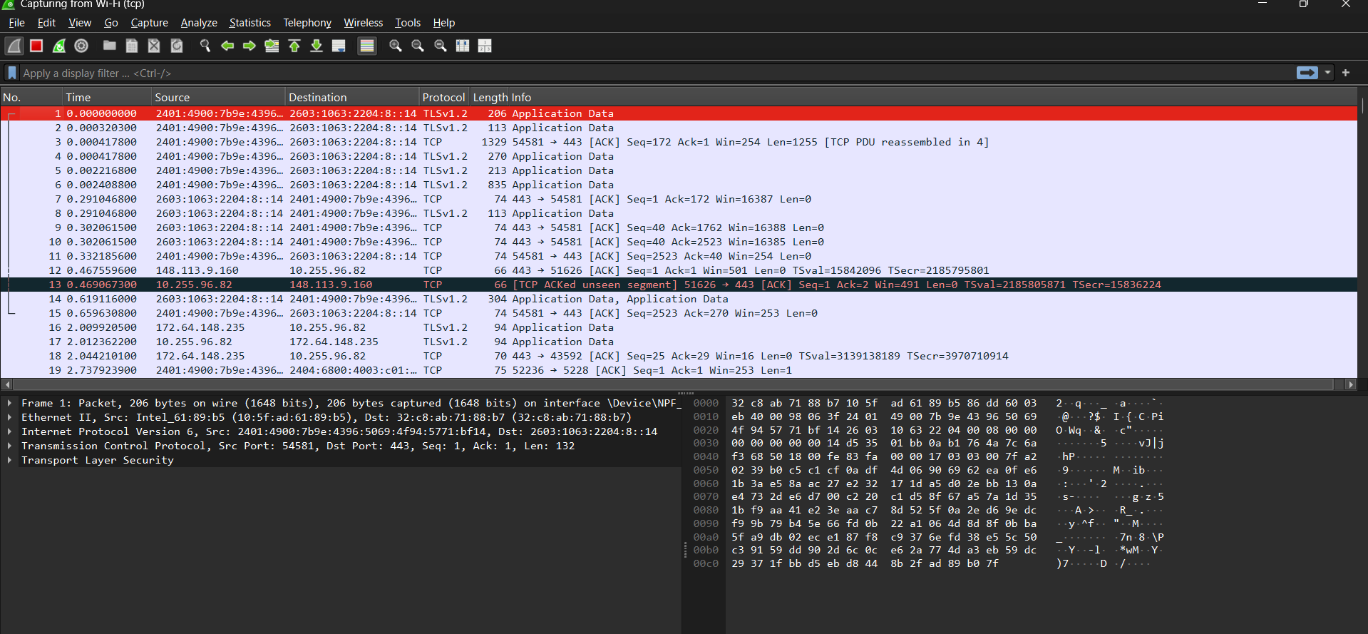
4. Understand linux utility commands like-ping, arp (Understand each params from ifconfig output)
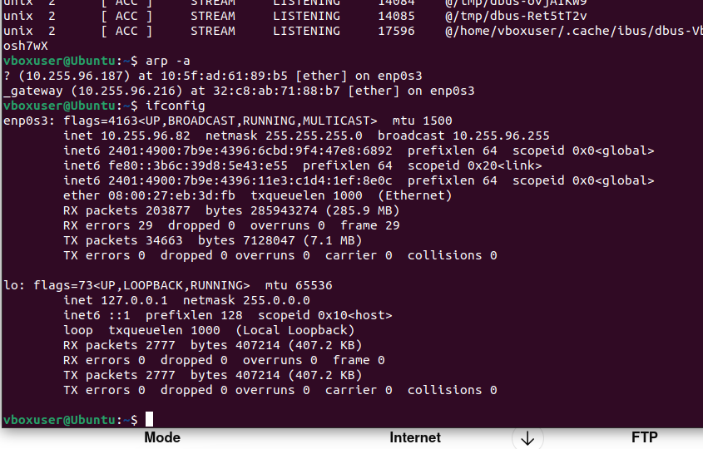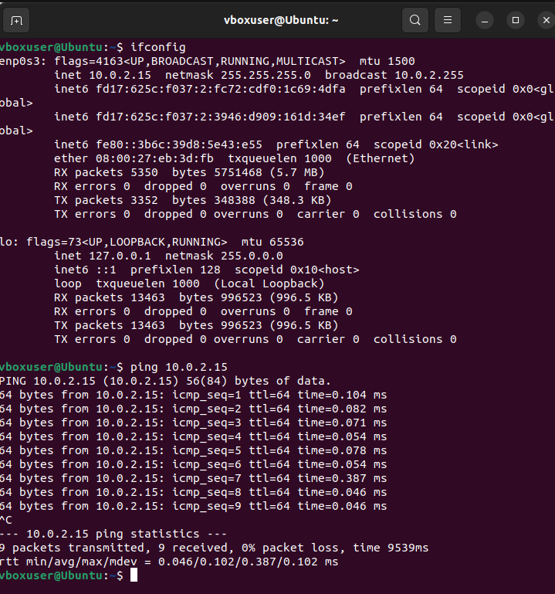

5. Understand what happens when duplicate IPs configured in a network.
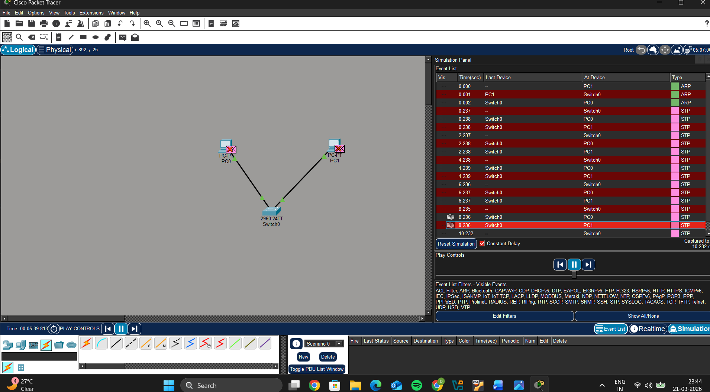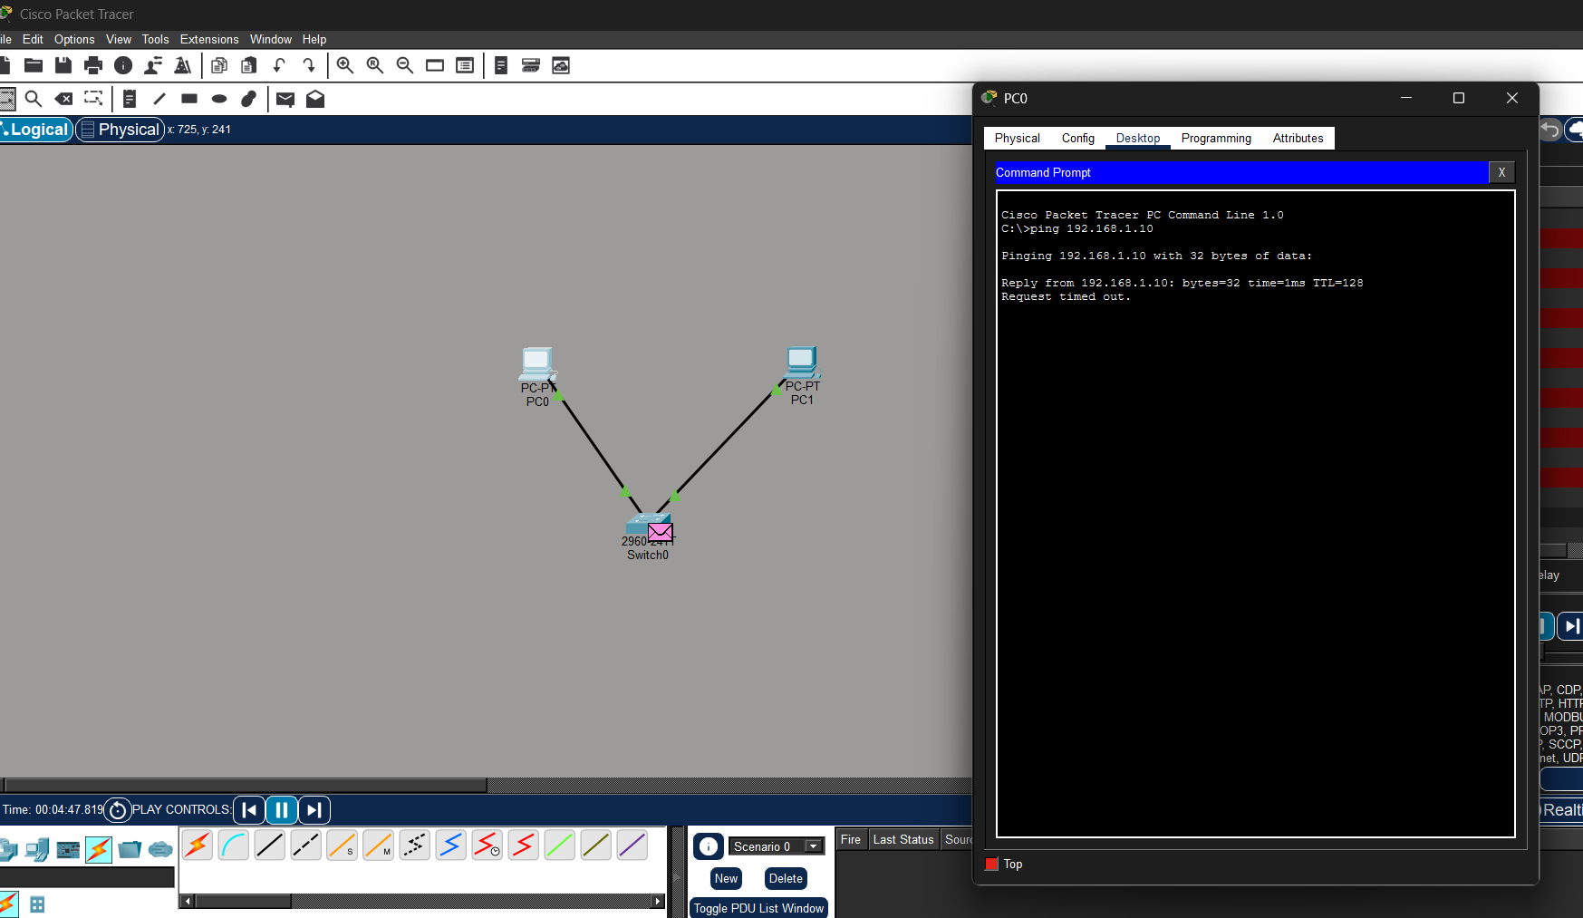

6. Understand how to access remote system using (VNC viewer, Anydesk, teamviewer and remote desktop connections)
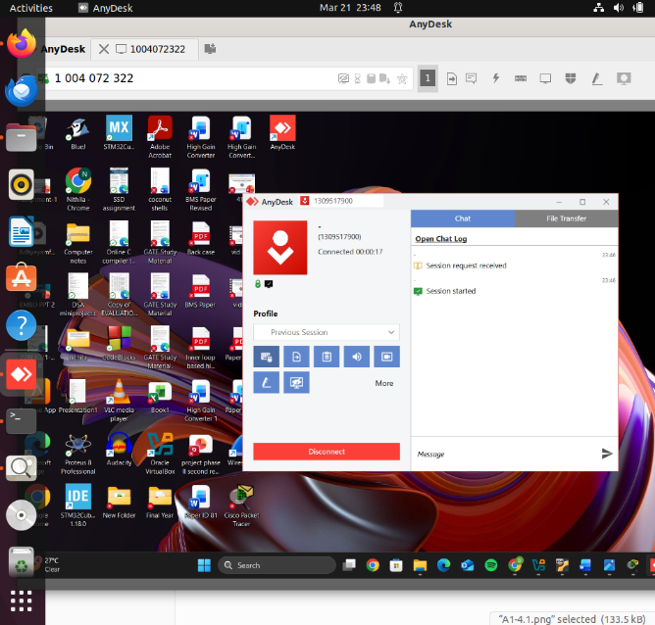

7. How to check your default gateway is reachable or not and understand about default gateway.
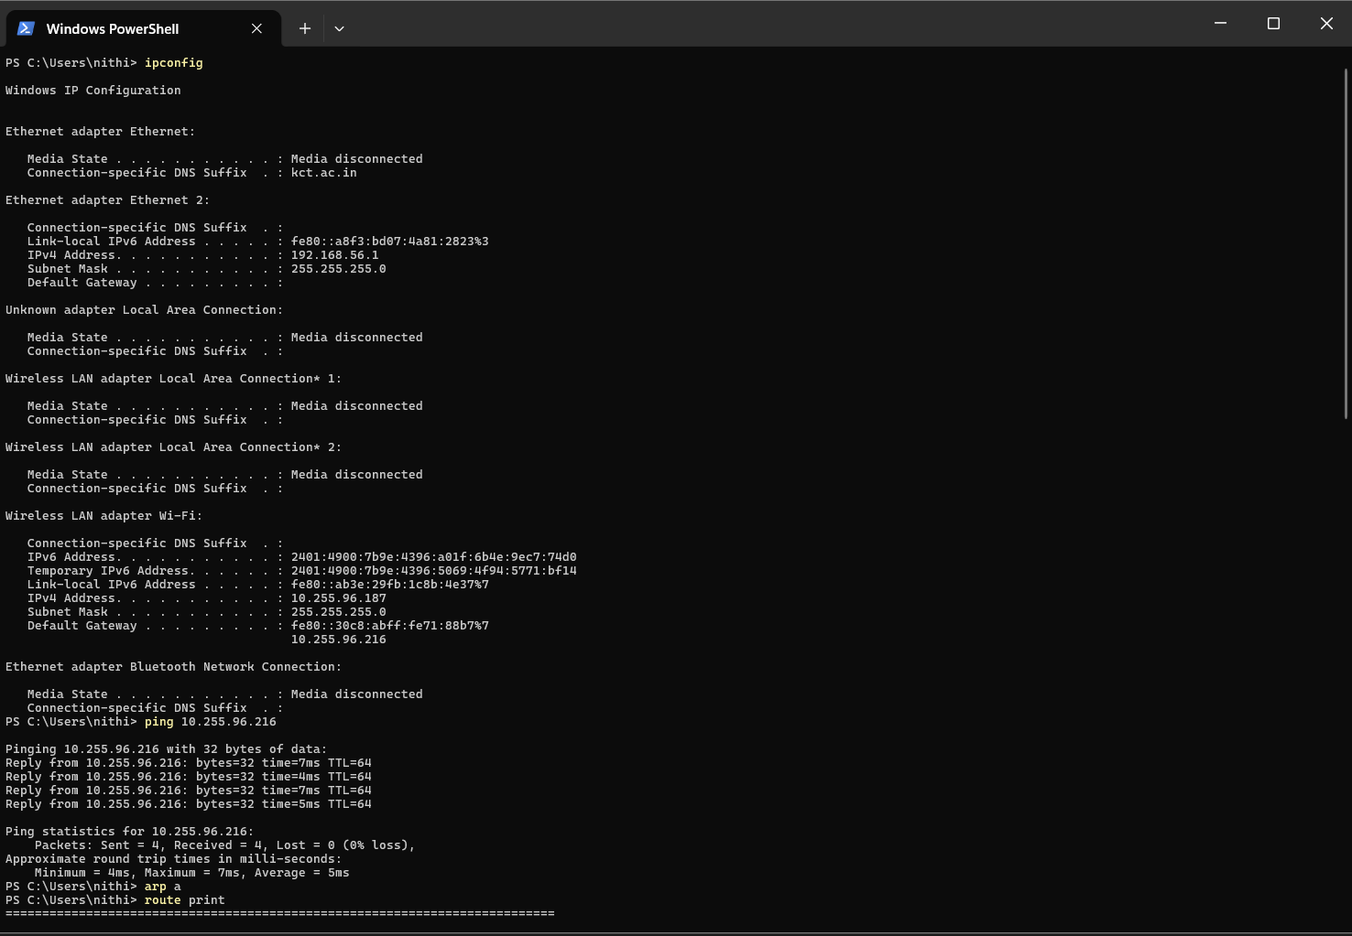

8. Check iwconfig/ifconfig to understand in detail about network interfaces (check about interface speed, MTU and other parameters)
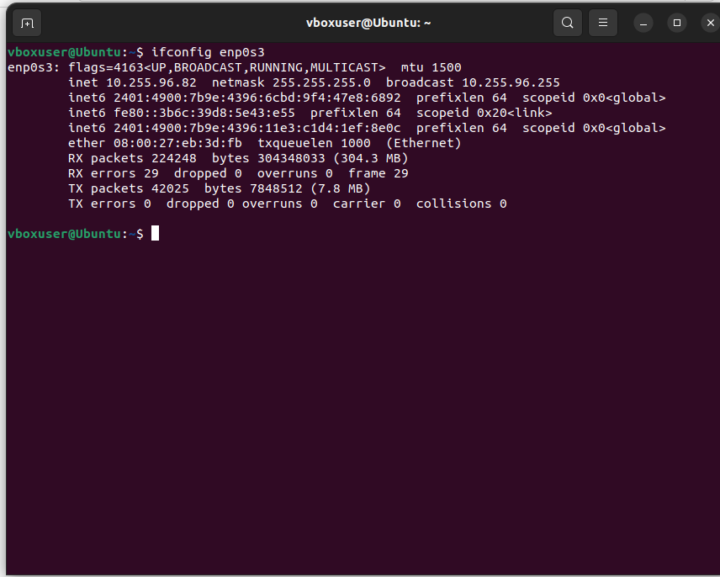
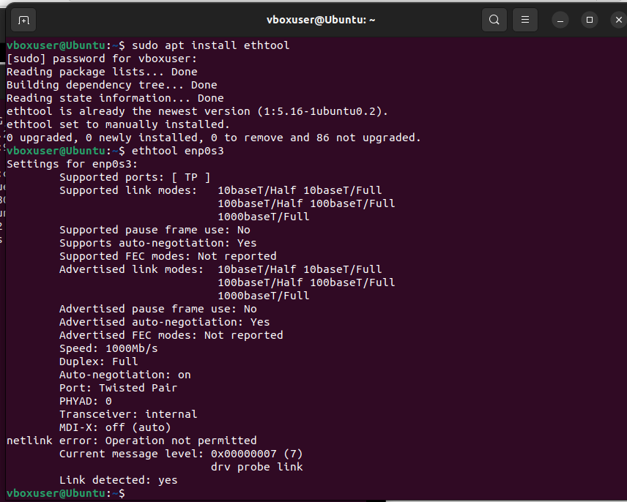

9. Log in to your home router's web interface (usually at 192.168.1.1 от 192.168.0.1) and check the connected devices list.

10. Explain how a DHCP server assigns IP addresses to devices in your network.
1. DHCP Discover
- A new device (client) joins the network and has no IP.
- It broadcasts a DHCP Discover message to locate available DHCP servers.
2. DHCP Offer
- DHCP server receives the discover message.
- It selects an available IP from its IP pool and sends a DHCP Offer to the client.
- The offer includes: IP address, subnet mask, default gateway, lease time, DNS servers.
3. DHCP Request
- The client responds with a DHCP Request, indicating it wants to use the offered IP.
- This message may also be broadcast so all DHCP servers know which IP the client accepted.
4. DHCP Acknowledge
- The DHCP server confirms with a DHCP ACK, officially leasing the IP to the client for a specific lease time.
- The client configures its network interface with the provided IP, gateway, and DNS.

11. Using a terminal, connect to a remote machine via SSH and telnet.
